# Hands-on Experiment # 10 : Worksheet

Section_____1_________ Date__________06/04/2020________________________

No more than 3 students per one submission of this worksheet.

Student ID ________6238218321 __________ Name______ Sippakorn Ornwichian___________

Student ID _________________________________ Name______________________________________

Student ID _________________________________ Name______________________________________

## Part A: Getting Familiar with Writing Recursive Methods

1. Consider the following recursive definition.



Find the value of *f(n)* for all values of *n* listed in the table below.

|  |  |
| --- | --- |
| *n* | *f(n)* |
| 0 | 1 |
| 1 | 1 |
| 2 | 1 |
| 3 | 3 |
| 4 | 5 |
| 5 | 9 |
| 6 | 17 |

1. Write a Java method called *computeF(int n)* which returns the value of *f(n)*. Assume that *n* is a non-negative integer. Test your method in a program in which the values of f(n) according to the following table are computed. Complete the table.

|  |  |  |  |
| --- | --- | --- | --- |
| *n* | *f(n)* | *n* | *f(n)* |
| 0 | 1 | 7 | 31 |
| 1 | 1 | 8 | 57 |
| 2 | 1 | 9 | 105 |
| 3 | 3 | 10 | 193 |
| 4 | 5 | 100 | 1.2707161788700277E26 |
| 5 | 9 | 200 | 3.7067466851909835E52 |
| 6 | 17 | 500 | 9.20080768385554E131 |

List all your source code below.

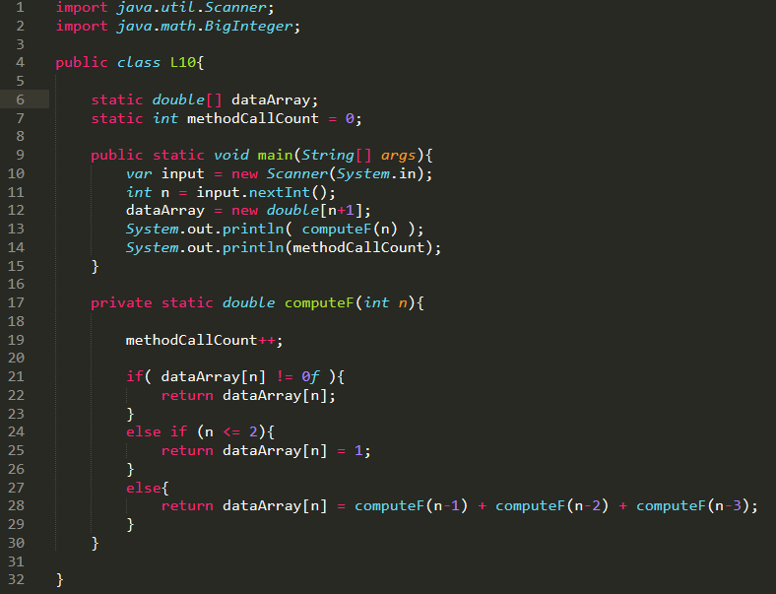

1. (Optional) Based on your code, how many times *computeF()* is called in order to compute *computeF(500)*? You may modify the signature of the method so that you have a way to track the number of times it is called.

The number of times is :

1495

Explain how you obtained the answer. Show all relevant code.

static int methodCallCount = 0; //declare integer variable for counting method calls

methodCallCount++; //increment methodCallCount each time computeF() is called

System.out.println(methodCallCount); //print out the number

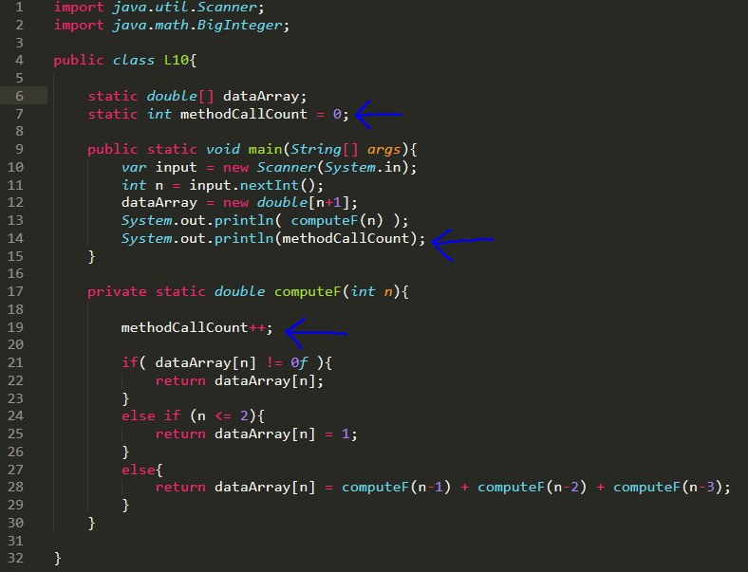

## Part B: Thinking Recursively

1. Write a recursive method that checks whether the input *String* is a palindrome (<http://en.wikipedia.org/wiki/Palindrome>). Assume that the input *String* only contains English alphabets. You can design the method signature by yourself.

List your source code here.

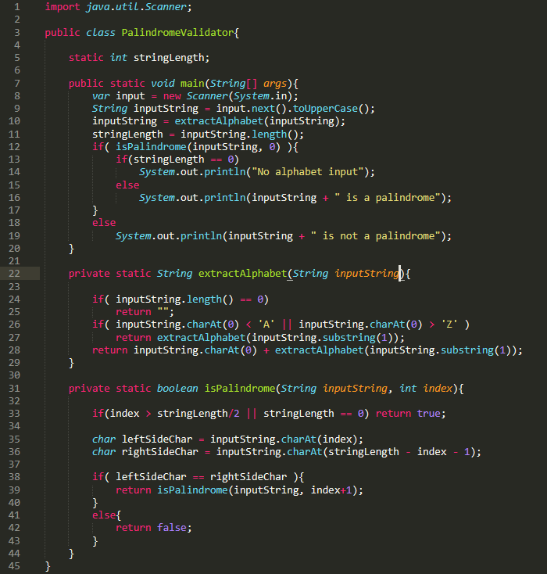

Submit this worksheet (by only one member of the group) via <http://www.myCourseVille.com> (Assignments > Hands-on Experiment # 10) before noon of the day after your lecture.